UNITED STATES

SECURITIES AND EXCHANGE COMMISSION
Washington, D.C. 20549

FORM 6-K

REPORT OF FOREIGN PRIVATE ISSUER PURSUANT TO RULE 13a-16 OR 15d-16 OF THE SECURITIES EXCHANGE ACT OF 1934

For the month of January 2025

Commission File Number 001-42254

Rezolve AI Limited

(Translation of registrant’s name into English)

3rd Floor, 80 New Bond Street

London, W1S 1SB

United Kingdom

(Address of principal executive offices)

Indicate by check mark whether the registrant files or will file annual reports under cover of Form 20-F or Form 40-F. Form 20-F ☒ Form 40-F ☐

INFORMATION CONTAINED IN THIS REPORT ON FORM 6-K

On January 21, 2025, the Company made available an investor presentation on its website. A copy of the investor presentation is attached hereto as Exhibit 99.1.

Exhibit

No. Description

99.1 Investor Presentation.

SIGNATURE

Pursuant to the requirements of the Securities Exchange Act of 1934, the registrant has duly caused this report to be signed on its behalf by the undersigned hereunto duly authorized.

Dated: January 21, 2025

By: | /s/ Daniel Wagner
Name: | Daniel Wagner
Title: | Chief Executive Officer and Chairman



Resolve Ai instant salesware Investor presentation January 2025

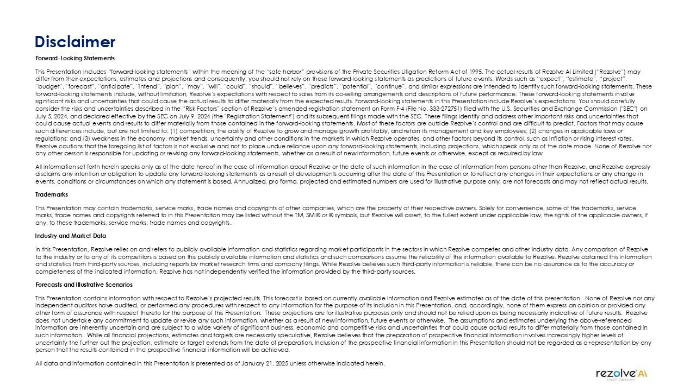

Disclaimer Forward-Looking Statements This Presentation includes “forward-looking statements” within the meaning of the “safe harbor” provisions of the Private Securities Litigation Reform Act of 1995. The actual results of Rezolve Ai Limited (“Rezolve”) may differ from their expectations, estimates and projections and consequently, you should not rely on these forward-looking statements as predictions of future events. Words such as “expect”, “estimate”, “project”, “budget”, “forecast”, “anticipate”, “intend”, “plan”, “may”, “will”, “could”, “should”, “believes”, “predicts”, “potential”, “continue”, and similar expressions are intended to identify such forward-looking statements. These forward-looking statements include, without limitation, Rezolve’s expectations with respect to sales from its co-selling arrangements and descriptions of future performance. These forward-looking statements involve significant risks and uncertainties that could cause the actual results to differ materially from the expected results. Forward-looking statements in this Presentation include Rezolve’s expectations You should carefully consider the risks and uncertainties described in the “Risk Factors” section of Rezolve’s amended registration statement on Form F-4 (File No. 333-272751) filed with the U.S. Securities and Exchange Commission ("SEC") on July 5, 2024, and declared effective by the SEC on July 9, 2024 (the "Registration Statement") and its subsequent filings made with the SEC. These filings identify and address other important risks and uncertainties that could cause actual events and results to differ materially from those contained in the forward-looking statements. Most of these factors are outside Rezolve’s control and are difficult to predict. Factors that may cause such differences include, but are not limited to: (1) competition, the ability of Rezolve to grow and manage growth profitably, and retain its management and key employees; (2) changes in applicable laws or regulations; and (3) weakness in the economy, market trends, uncertainty and other conditions in the markets in which Rezolve operates, and other factors beyond its control, such as inflation or rising interest rates. Rezolve cautions that the foregoing list of factors is not exclusive and not to place undue reliance upon any forward-looking statements, including projections, which speak only as of the date made. None of Rezolve nor any other person is responsible for updating or revising any forward-looking statements, whether as a result of new information, future events or otherwise, except as required by law. All information set forth herein speaks only as of the date hereof in the case of information about Rezolve or the date of such information in the case of information from persons other than Rezolve, and Rezolve expressly disclaims any intention or obligation to update any forward-looking statements as a result of developments occurring after the date of this Presentation or to reflect any changes in their expectations or any change in events, conditions or circumstances on which any statement is based. Annualized, pro forma, projected and estimated numbers are used for illustrative purpose only, are not forecasts and may not reflect actual results. Trademarks This Presentation may contain trademarks, service marks, trade names and copyrights of other companies, which are the property of their respective owners. Solely for convenience, some of the trademarks, service marks, trade names and copyrights referred to in this Presentation may be listed without the TM, SM © or ® symbols, but Rezolve will assert, to the fullest extent under applicable law, the rights of the applicable owners, if any, to these trademarks, service marks, trade names and copyrights. Industry and Market Data In this Presentation, Rezolve relies on and refers

to publicly available information and statistics regarding market participants in the sectors in which Rezolve competes and other industry data. Any comparison of Rezolve to the industry or to any of its competitors is based on this publicly available information and statistics and such comparisons assume the reliability of the information available to Rezolve. Rezolve obtained this information and statistics from third-party sources, including reports by market research firms and company filings. While Rezolve believes such third-party information is reliable, there can be no assurance as to the accuracy or completeness of the indicated information. Rezolve has not independently verified the information provided by the third-party sources. Forecasts and Illustrative Scenarios This Presentation contains information with respect to Rezolve’s projected results. This forecast is based on currently available information and Rezolve estimates as of the date of this presentation. None of Rezolve nor any independent auditors have audited, or performed any procedures with respect to any information for the purpose of its inclusion in this Presentation, and, accordingly, none of them express an opinion or provided any other form of assurance with respect thereto for the purpose of this Presentation. These projections are for illustrative purposes only and should not be relied upon as being necessarily indicative of future results. Rezolve does not undertake any commitment to update or revise any such information, whether as a result of new information, future events or otherwise. The assumptions and estimates underlying the above-referenced information are inherently uncertain and are subject to a wide variety of significant business, economic and competitive risks and uncertainties that could cause actual results to differ materially from those contained in such information. While all financial projections, estimates and targets are necessarily speculative, Rezolve believes that the preparation of prospective financial information involves increasingly higher levels of uncertainty the further out the projection, estimate or target extends from the date of preparation. Inclusion of the prospective financial information in this Presentation should not be regarded as a representation by any person that the results contained in the prospective financial information will be achieved. All data and information contained in this Presentation is presented as of January 21, 2025 unless otherwise indicated herein. (company logo)

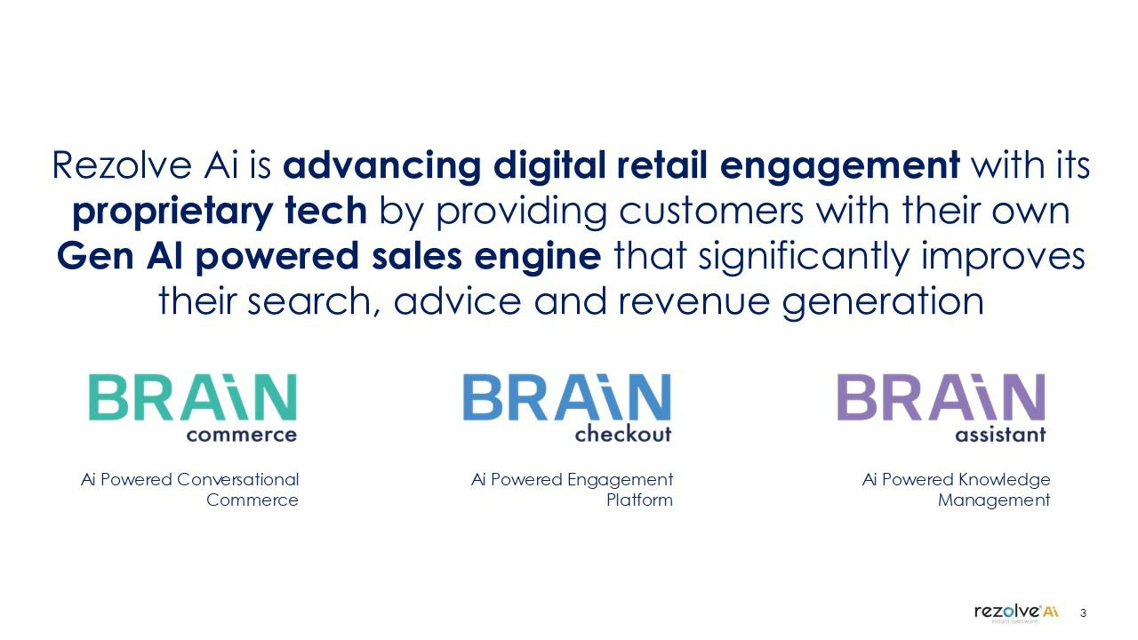

Rezolve Ai is advancing digital retail engagement with its proprietary tech by providing customers with their own Gen AI powered sales engine that significantly improves their search, advice and revenue generation BRAiN commerce BRAiN checkout BRAiN assistant Ai Powered Conversational Commerce Ai Powered Engagement Platform Ai Powered Knowledge Management 3 (company logo)

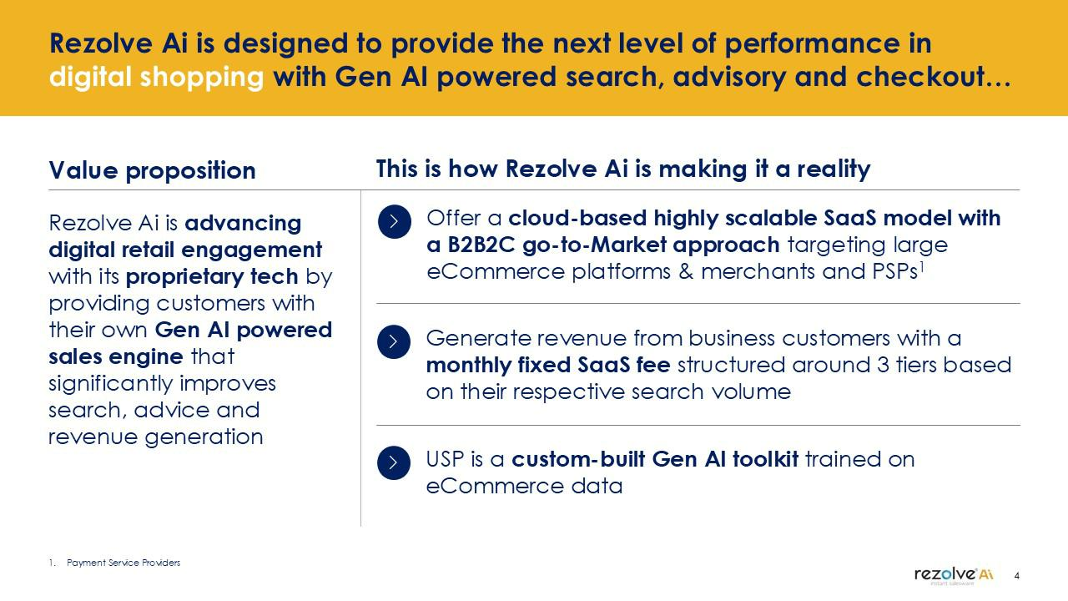

Rezolve Ai is designed to provide the next level of performance in digital shopping with Gen AI powered search, advisory and checkout… Value proposition Rezolve Ai is advancing digital retail engagement with its proprietary tech by providing customers with their own Gen AI powered sales engine that significantly improves search, advice and revenue generation This is how Rezolve Ai is making it a reality Offer a cloud-based highly scalable SaaS model with a B2B2C go-to-Market approach targeting large eCommerce platforms & merchants and PSPs¹ Generate revenue from business customers with a monthly fixed SaaS fee structured around 3 tiers based on their respective search volume USP is a custom-built Gen AI toolkit trained on eCommerce data Payment Service Providers 4 (company logo)



…through a suite of Gen AI-enabled solutions powered by Rezolve Ai’s foundational LLM brainpowa From… Cumbersome search Multi-step journey Generic LLMs To… Highly personalized Seamless journey eCommerce focused LLM 5 (Company logo)

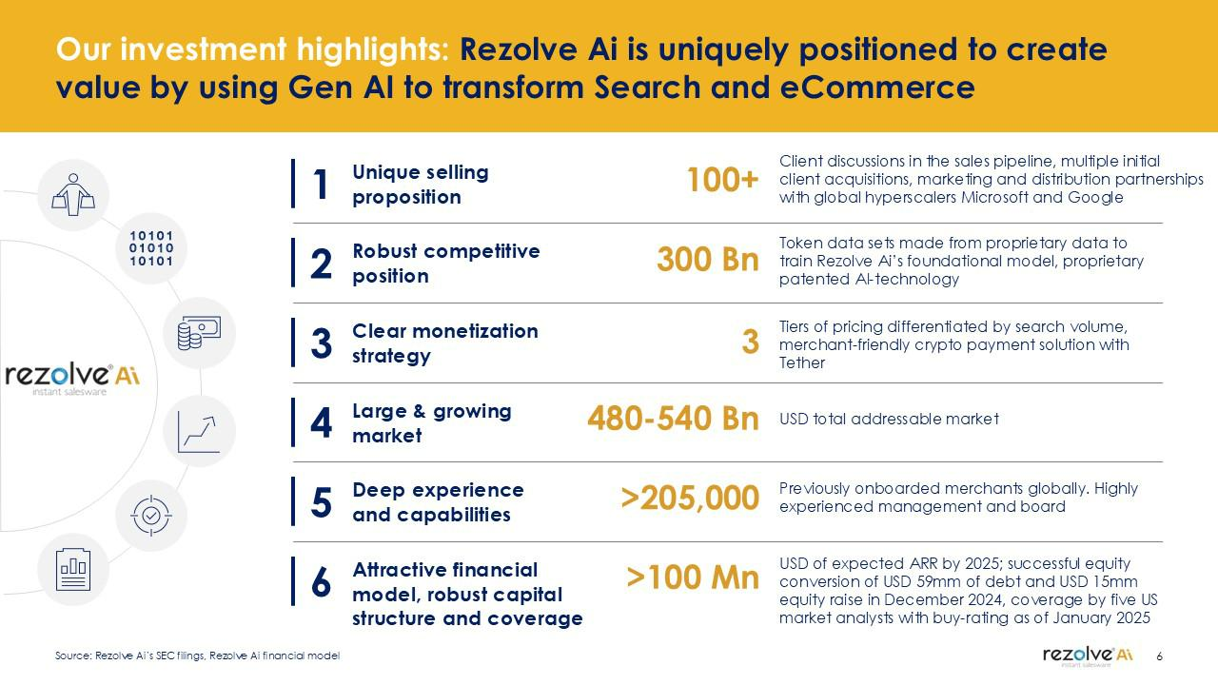

Our investment highlights: Rezolve Ai is uniquely positioned to create value by using Gen AI to transform Search and eCommerce 1 Unique selling proposition 2 Robust competitive position 3 Clear monetization strategy 4 Large & growing market 5 Deep experience and capabilities 6 Attractive financial model, robust capital structure and coverage 100+ Client discussions in the sales pipeline, multiple initial client acquisitions, marketing and distribution partnerships with global hyperscalers Microsoft and Google 300 Bn Token data sets made from proprietary data to train Rezolve Ai’s foundational model, proprietary patented AI-technology 3 Tiers of pricing differentiated by search volume, merchant-friendly crypto payment solution with Tether 480-540 Bn USD total addressable market >205,000 Previously onboarded merchants globally. Highly experienced management and board >100 Mn USD of expected ARR by 2025; successful equity conversion of USD 59mm of debt and USD 15mm equity raise in December 2024, coverage by five US market analysts with buy-rating as of January 2025 Source: Rezolve Ai’s SEC filings, Rezolve Ai financial model 6 (Company logo)

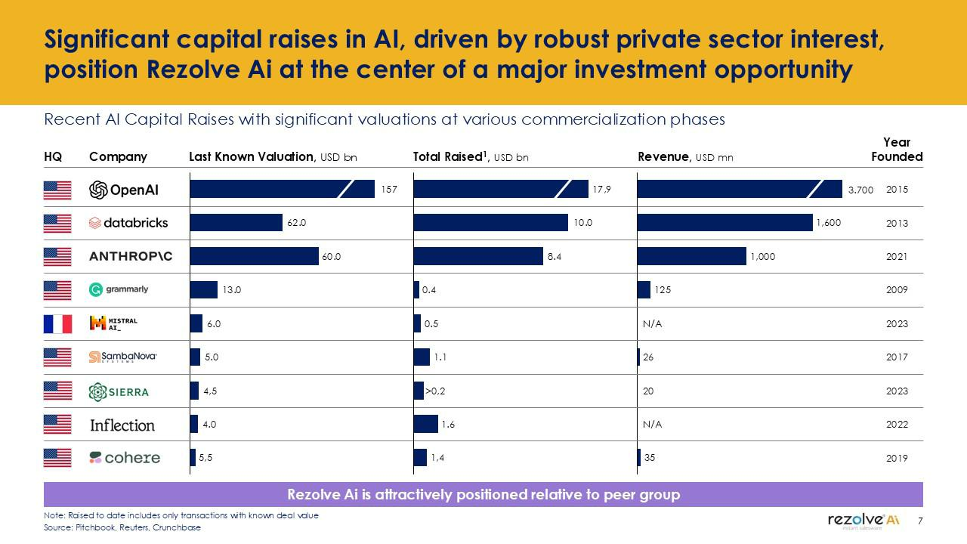

Significant capital raises in AI, driven by robust private sector interest, position Rezolve Ai at the center of a major investment opportunity Recent AI Capital Raises with significant valuations at various commercialization phases HQ Company Last Known Valuation, USD bn Total Raised1, USD bn Revenue, USD mn Year Founded OpenAI databricks ANTHROP\C Grammarly MISTRAL Sambanova SIERRA Inflection cohere 1.57 62.0 60.0 13.0 6.0 5.0 4,5 4.0 5,5 17,9 10.0 8.4 0.4 0.5 1.1 >0,2 1.6 1,4 3.700 2015 1,600 2013 1,000 2021 125 2009 N/A 2023 26 2017 20 2023 N/A 2022 35 2019 Rezolve Ai is attractively positioned relative to peer group Note: Raised to date includes only transactions with known deal value Source: Pitchbook, Reuters, Crunchbase 7 (Company logo)



1 Unique selling proposition

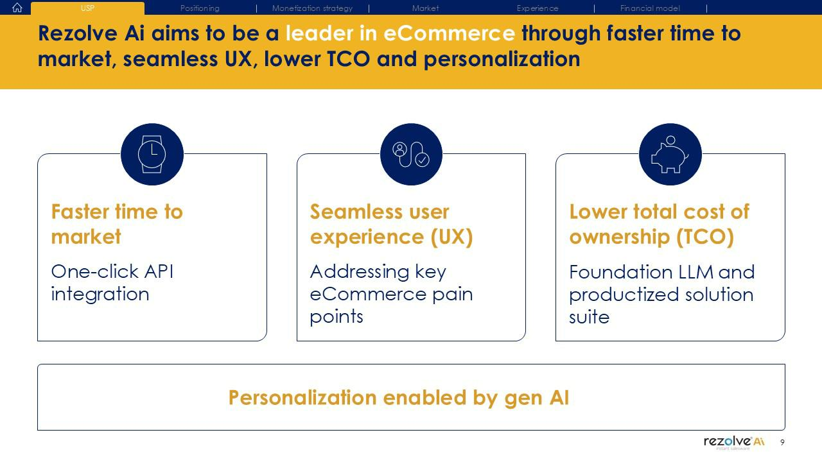

USP Positioning Monetization strategy Market Experience Financial model Rezolve Ai aims to be a leader in eCommerce through faster time to market, seamless UX, lower TCO and personalization Faster time to market One-click API integration Seamless user experience (UX) Addressing key eCommerce pain points Lower total cost of ownership (TCO) Foundation LLM and productized solution suite Personalization enabled by gen AI 9 (Company logo)



