Filed by Rezolve AI plc
Pursuant to Rule 425 under the Securities Act of 1933
and deemed filed pursuant to Rule 14a-12
under the Securities Exchange Act of 1934
Subject Company: Commerce.com, Inc.
(Commission File No. 001-39423)

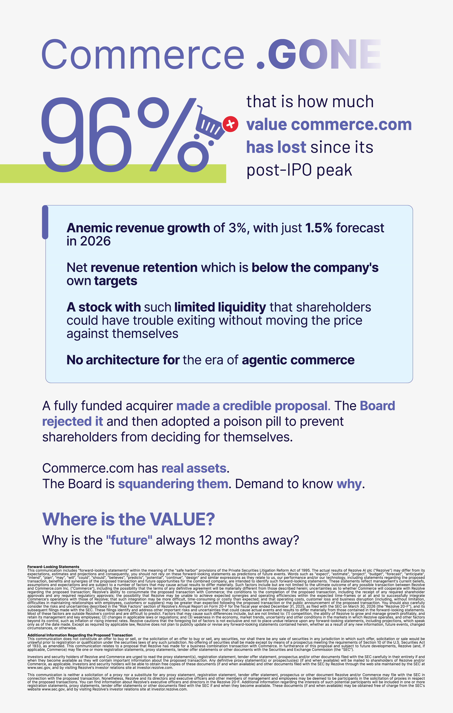

Commerce. GONE 96% that is how much value commerce.com has lost since its post-IPO peak Anemic revenue growth of 3%, with just 1.5% forecast in 2026 Net revenue retention which is below the company's own targets A stock with such limited liquidity that shareholders could have trouble exiting without moving the price against themselves No architecture for the era of agentic commerce A fully funded acquirer made a credible proposal. The Board rejected it and then adopted a poison pill to prevent shareholders from deciding for themselves. Commerce.com has real assets. The Board is squandering them. Demand to know why. Where is the VALUE? Why is the "future" always 12 months away? Forward-Looking Statements This communication includes "forward-looking statements" within the meaning of the "safe harbor" provisions of the Private Securities Litigation Reform Act of 1995. The actual results of Rezolve AI plc ("Rezolve") may differ from its expectations, estimates and projections and consequently, you should not rely on these forward-looking statements as predictions of future events. Words such as "expect", "estimate", "project", "budget", "forecast", "anticipate", "intend", "plan", "may", "will", "could", "should", "believes", "predicts", "potential", "continue", "design" and similar expressions as they relate to us, our performance and/or our technology, including statements regarding the proposed transaction, benefits and synergies of the proposed transaction and future opportunities for the combined company, are intended to identify such forward-looking statements. These statements reflect management's current beliefs, assumptions and expectations and are subject to a number of factors that may cause actual results to differ materially. Such factors include but are not limited to the ultimate outcome of any possible transaction between Rezolve and Commerce.com Inc. ("Commerce"), including the possibility that the terms of any definitive agreement will be materially different from those described herein; uncertainties as to whether Commerce will cooperate with Rezolve regarding the proposed transaction; Rezolve's ability to consummate the proposed transaction with Commerce; the conditions to the completion of the proposed transaction, including the receipt of any required shareholder approvals and any required regulatory approvals; the possibility that Rezolve may be unable to achieve expected synergies and operating efficiencies within the expected time-frames or at all and to successfully integrate Commerce's operations with those of Rezolve; that such integration may be more difficult, time-consuming or costly than expected; and that operating costs, customer loss and business disruption (including, without limitation, difficulties in maintaining relationships with employees, customers or suppliers) may be greater than expected following the proposed transaction or the public announcement of the proposed transaction. You should also carefully consider the risks and uncertainties described in the "Risk Factors" section of Rezolve's Annual Report on Form 20-F for the fiscal year ended December 31, 2025, as filed with the SEC on March 30, 2026 (the "Rezolve 20-F"), and its subsequent filings made with the SEC. These filings identify and address other important risks and uncertainties that could cause actual events and results to differ materially from those contained in the forward-looking statements. Most of these factors are outside Rezolve's control and are difficult to predict. Factors that may cause such differences include, but are not limited to: (1) competition, the ability of Rezolve to grow and manage growth profitably, and retain its management and key employees; (2) changes in applicable laws or regulations; and (3) weakness in the economy, market trends, uncertainty and other conditions in the markets in which Rezolve operates, and other factors beyond its control, such as inflation or rising interest rates. Rezolve cautions that the foregoing list of factors is not exclusive and not to place undue reliance upon any forward-looking statements, including projections, which speak only as of the date made. Except as required by applicable law, Rezolve does not plan to publicly update or revise any forward-looking statements contained herein, whether as a result of any new information, future events, changed circumstances, or otherwise. Additional Information Regarding the Proposed Transaction This communication does not constitute an offer to buy or sell, or the solicitation of an offer to buy or sell, any securities, nor shall there be any sale of securities in any jurisdiction in which such offer, solicitation or sale would be unlawful prior to registration or qualification under the securities laws of any such jurisdiction. No offering of securities shall be made except by means of a prospectus meeting the requirements of Section 10 of the U.S. Securities Act of 1933, as amended. This communication relates to a proposal that Rezolve has made for a business combination transaction with Commerce. In furtherance of this proposal and subject to future developments, Rezolve (and, if applicable, Commerce) may file one or more registration statements, proxy statements, tender offer statements or other documents with the Securities and Exchange Commission (the "SEC"). Investors and security holders of Rezolve and Commerce are urged to read the proxy statement(s), registration statement, tender offer statement, prospectus and/or other documents filed with the SEC carefully in their entirety if and when they become available as they will contain important information about the proposed transaction. Any definitive proxy statement(s) or prospectus(es) (if and when available) will be mailed to shareholders of Rezolve and/or Commerce, as applicable. Investors and security holders will be able to obtain free copies of these documents (if and when available) and other documents filed with the SEC by Rezolve through the web site maintained by the SEC at www.sec.gov, and by visiting Rezolve's investor relations site at investor.rezolve.com. This communication is neither a solicitation of a proxy nor a substitute for any proxy statement, registration statement, tender offer statement, prospectus or other document Rezolve and/or Commerce may file with the SEC in connection with the proposed transaction. Nonetheless, Rezolve and its directors and executive officers and other members of management and employees may be deemed to be participants in the solicitation of proxies in respect of the proposed transactions. You can find information about Rezolve's executive officers and directors in the Rezolve 20-F. Additional information regarding the interests of such potential participants will be included in one or more registration statements, proxy statements, tender offer statements or other documents filed with the SEC if and when they become available. These documents (if and when available) may be obtained free of charge from the SEC's website www.sec.gov, and by visiting Rezolve's investor relations site at investor.rezolve.com.



AI-DRIVEN ECOMMERCE IS FORECAST TO REACH $144 Billion BY 2029 Rezolve AI Advanced Commerce technologies Rezolve AI is already executing a clear plan to realize the next era of commerce. By combining our businesses we can create: A hyper scaler helping retailers capitalize on the agentic commerce opportunity 60,000 storefronts paired with Brain Suite and RezolvePay as standard brainpowa, a commerce-specific AI model which improves with every sale $700 million-plus in combined revenue, >90% core software margins, as the baseline Ask your Board one question What is your timeline to deliver such results? Stop waiting for the roadmap Start investing in the reality

