UNITED STATES

SECURITIES AND EXCHANGE COMMISSION
Washington, D.C. 20549

FORM 6-K

REPORT OF FOREIGN PRIVATE ISSUER PURSUANT TO RULE 13a-16 OR 15d-16 OF THE SECURITIES EXCHANGE ACT OF 1934

For the month of June 2026

Commission File Number 001-42254

Rezolve AI plc

(Translation of registrant’s name into English)

21 Sackville Street,

London, W1S 3DN

United Kingdom

(Address of principal executive offices)

Indicate by check mark whether the registrant files or will file annual reports under cover of Form 20-F or Form 40-F. Form 20-F ☒ Form 40-F ☐

INFORMATION CONTAINED IN THIS REPORT ON FORM 6-K

Annual General Meeting

The Annual General Meeting of Shareholders (the “Meeting”) of Rezolve AI plc (the “Company”), will be held on Tuesday, June 30, 2026, at 2:00 p.m. (UK time), at 21 Sackville Street, London W1S 3DN. The Company has distributed a Notice of Annual General Meeting of Shareholders and a Proxy Card to its shareholders. In connection with the Meeting, the Company hereby furnishes the following documents:

1.Notice of Annual General Meeting of Shareholders with respect to the Company’s Meeting describing proposals to be voted upon at the Meeting; and

2.Proxy Card whereby holders of ordinary shares of the Company may vote at the Meeting without attending in person.

A copy of the Notice of General Meeting of Shareholders and Proxy Card are furnished as Exhibit 99.1 and 99.2 to this Report on Form 6-K, respectively, and are incorporated herein by reference.

Press Release

On June 12, 2026, the Company issued a press release announcing its plan to seek authorization to approve a capital reduction and to repurchase up to $300 million of ordinary shares, a copy of which is furnished herewith as Exhibit 99.3.

The information included under the heading “Press Release” (including Exhibit 99.3 to this Report on Form 6-K) is being furnished and shall not be deemed "filed" for purposes of Section 18 of the Securities Exchange Act of 1934, as amended (the "Exchange Act"), or otherwise subject to the liabilities of that section, nor shall it be deemed incorporated by reference in any filing under the Securities Act of 1933, as amended, or the Exchange Act, except as otherwise set forth herein or as shall be expressly set forth by specific reference in such filing.

Exhibit No. | Description
99.1 | Notice of Annual General Meeting of Shareholders.
99.2 | Proxy Card.
99.3 | Press Release dated June 12, 2026.

SIGNATURE

Pursuant to the requirements of the Securities Exchange Act of 1934, the registrant has duly caused this report to be signed on its behalf by the undersigned hereunto duly authorized.

Dated: June 12, 2026

By: | /s/ Daniel Wagner
Name:
Name: | Daniel Wagner
Title: | Chief Executive Officer and Chairman

Exhibit 99.1

Notice of Annual General Meeting 2026

REZOLVE AI PLC

THIS DOCUMENT IS IMPORTANT AND REQUIRES YOUR IMMEDIATE ATTENTION. If you have any doubts about the action you should take, you should consult your stockbroker, bank manager, solicitor, accountant, or other independent financial adviser authorised under the Financial Services and Markets Act 2000 if you are in the United Kingdom or from another appropriately authorised independent financial adviser if you are taking advice in a territory outside of the United Kingdom.

If you have sold or otherwise transferred all of your shares, please pass this document and its enclosures to the stockbroker or other agent through whom the sale was effected, for transmission to the purchaser or transferee.

Dear Shareholder

The following document gives notice that the Annual General Meeting (“AGM”) of Rezolve AI PLC (the “Company”) will be held at 2:00 p.m.

(UK time) (9:00 a.m. (EDT)) on 30 June 2026 at 21 Sackville Street, London W1S 3DN.

As always, your vote is important to us and we encourage you to vote by completing and submitting a proxy form.

Business of the AGM

Included in the business of the AGM are:

- customary resolutions to: (i) receive and adopt the annual accounts; (ii) approve the Directors’ Report for the year ended 31 December 2025; (iii) approve an annual report on remuneration for the year ended 31 December 2025; (iv) re-elect certain directors as directors of the Company; and (v) confirm the appointment of Macalvins Limited as the company’s auditor; and

- special business resolutions to seek shareholder approval of: (i) the terms of a buyback contract which would enable the Company to carry out share buybacks of its ordinary shares of £0.0001 each; and (ii) a proposed capital reduction.

A copy of the Financial Statements and Directors’ Report for the year ended 31 December 2025 and the remuneration report for the year ended 31 December 2025 are enclosed with this notice.

Voting at the AGM

Voting at the AGM will be by way of poll rather than on a show of hands. This is a more transparent method of voting as shareholder votes are counted according to the number of shares held and will help to ensure an exact and definitive result. The poll will be conducted at the physical meeting. If you will not be participating in the meeting in person or otherwise wish to vote in advance, you may appoint a proxy as further detailed on page 7. Those submitting a proxy are encouraged to consider appointing the Chair of the meeting, rather than some other named person, as their proxy. This will ensure that your vote is counted.

Recommendation

The board of directors of the Company considers that the resolutions contained in this Notice are in the best interests of your Company and the shareholders as a whole and recommends that you vote in favour of them. The Directors intend to vote in favour of the resolutions in respect of their own beneficial holdings.

Yours sincerely

/s/ Daniel Wagner
Daniel Wagner
Chair and CEO

Rezolve AI PLC

Incorporated and registered in England under number 14573691 Registered office: 21 Sackville Street, London W1S 3DN

2

Notice is hereby given that an Annual General Meeting (“AGM”) of Rezolve AI PLC (the “Company”) will be held at 2:00 p.m. (UK time) (9:00 a.m. (EDT)) on 30 June 2026 at 21 Sackville Street, London W1S 3DN.

The business of the AGM will be to consider and, if thought fit, pass the following resolutions.

Resolutions 1 – 6 will be proposed as ordinary resolutions. Resolution 7 will be proposed as a special resolution. Explanations of the resolutions are given on page 5 of this Notice. Additional information for those entitled to attend the AGM can be found on page 7 of this Notice.

ORDINARY RESOLUTIONS

Resolution 1 –Report and accounts 2025

THAT the Directors’ report and the accounts for the year ended 31 December 2025 be received and adopted.

Resolution 2 –Remuneration report 2025

THAT the annual report on remuneration for the year ended 31 December 2025 be approved.

Resolution 3 –Re-election of directors

THAT each of Stephen Perry, Derek Smith, Sir David Wright and Anthony Sharp be re-elected as directors of the Company.

Resolution 4 –Appointment of auditor

THAT Macalvins Limited be appointed as auditor of the Company to hold office from the conclusion of this meeting until the conclusion of the next general meeting at which accounts are laid before the Company.

Resolution 5 –Remuneration of auditor

THAT the board of directors of the Company be authorised to determine the auditor’s remuneration.

Resolution 6 –share buyback contract

THAT for the purposes of Section 694 of the Companies Act 2006, the terms of the buyback contract proposed to be entered into by the Company (the “Buyback Contract”) pursuant to which the Company will make purchases of its ordinary shares of £0.0001 each (the “Ordinary Shares”) be and are approved, and the Company be and is authorised to purchase Ordinary Shares pursuant to the Buyback Contract, provided that such authority shall expire on 29 June 2031 but so that the Company may under the terms of the Buyback Contract enter into an agreement to purchase Ordinary Shares which will or may be completed or executed wholly or partly after the authority expires and the Company may purchase Ordinary Shares pursuant to any such agreement as if the authority had not expired.

SPECIAL RESOLUTION

Resolution 7 –Capital reduction

THAT £480 million of the amount standing to the credit of the share premium account of the Company be cancelled.

Dated: 4 June 2026

3

Registered Office:

21 Sackville Street

London
England

W1S 3DN

/s/ Daniel Wagner
BY ORDER OF THE BOARD
Director

Incorporated and registered in England under number 14573691

4

Explanatory notes on the resolutions

The notes on this page give an explanation of the proposed resolutions.

Resolutions 1 - 6 are proposed as ordinary resolutions, which require at least a simple majority of the votes cast to be in favour.

Resolution 7 is proposed as a special resolution, which requires at least three-quarters of the votes cast to be in favour.

ORDINARY RESOLUTIONS

Resolution 1 –Approval and adoption of annual accounts and Directors’ report 2025

The Directors are required to present to shareholders at a general meeting the Company’s accounts and the report of the Directors for the year ended 31 December 2025.

Resolution 8 –Approval of remuneration report 2025

This resolution seeks shareholder approval for the annual report on remuneration, which gives details of how payments and share awards were made to Directors in connection with their performance and that of the Company during the year ended 31 December 2025.

The remuneration report is prepared annually and is subject to an advisory shareholder vote.

Resolution 9 –Re-election of directors

In accordance with the Company’s articles of association, each of the Company’s directors was classified, with respect to the term for which they severally hold office, into three classes, designated as Class I, Class Il and Class III, respectively. The Class I director served a term expiring at the Company’s 2025 annual meeting of shareholders, the Class II directors serve a term expiring at the Company’s 2026 annual meeting of shareholders and the Class III directors serve a term expiring at the Company’s 2027 annual meeting of shareholders.

Each of Stephen Perry, Derek Smith, Sir David Wright and Anthony Sharp have been designated by a resolution adopted by the board of directors of the Company as Class II directors and, accordingly, their respective terms as directors of the Company expire upon conclusion of the AGM.

It is proposed, with the recommendation of the Board, that each of Stephen Perry, Derek Smith, Sir David Wright and Anthony Sharp be re-appointed as directors of the Company with effect from the conclusion of the AGM.

The bios of each of Stephen Perry, Derek Smith, Sir David Wright and Anthony Sharp may be found at https://investor.rezolve.com/corporate-governance/board-of-directors.

Resolution 10 –Approval of appointment of auditor

At each general meeting at which the accounts are laid before the shareholders, the Company is required to appoint an auditor to serve until the next such meeting. The board of directors of the Company has assessed the effectiveness of Macalvins Limited and recommends their appointment as auditor.

Macalvins Limited has agreed to act as the Company’s auditor in respect of the financial year ending 31 December 2026.

5

Resolution 11 –Remuneration of auditor

This resolution authorises the board of directors of the Company to determine the remuneration of the Company’s auditor.

Resolution 12 –Share buyback contract

This resolution seeks shareholder approval for the Buyback Contract, pursuant to section 694 of the Companies Act 2006.

Under the Buyback Contract, a maximum number of Ordinary Shares may be repurchased by the Company, subject to customary pricing thresholds. The Buyback Contract will be available for inspection at the Company’s registered office for not less than 15 days ending with the date of the AGM, and at the AGM itself.

SPECIAL RESOLUTION

Resolution 13 –Capital reduction

This resolution seeks shareholder approval for the cancellation of £480 million of the Company’s share premium account. The share premium account is not distributable and the cancellation will create a distributable reserve which may be used to offset a negative accumulated balance on the Company’s profit and loss account and create a surplus, which may be used by the Company to effect share buybacks.

The capital reduction is subject to court approval. Following the passing of this resolution, the Company will apply to the High Court of Justice of England and Wales for an order confirming the reduction.

6

Additional information for those entitled to attend the Annual General Meeting

- A member entitled to attend and vote at the AGM is entitled to appoint another person as his/her proxy to exercise all or any of his/her rights to attend, speak and vote at the meeting and at any adjournment of it (including on any poll demanded at the meeting or any adjourned meeting). Such a member may appoint more than one proxy in relation to the AGM, provided that each proxy is appointed to exercise the rights attached to a different share or shares held by that member. A proxy need not be a member of the Company.

- A form of proxy which may be used to appoint a proxy and give proxy instructions is enclosed (the “Form of Proxy”).

- To be valid, a copy of the completed and signed instrument appointing a proxy, and the power of attorney or other authority (if any) under which it is signed, must be returned in accordance with the instructions in the top right corner of the first page of the Form of Proxy, so as to be received as soon as possible and in any event not later than 11:59 p.m. (EDT) on 26 June 2026 (or, in the case of an adjournment of the meeting, 48 hours before the time appointed for the adjourned meeting (provided that for these purposes no account shall be taken of any part of a day that is not a working day)).

- The return of a completed and signed instrument appointing a proxy, and the power of attorney or other authority (if any) under which it is signed, will not prevent a shareholder attending the meeting and voting in person should they wish to do so, subject to any restrictions regarding in person attendance at the meeting that may be introduced.

- A member which is a corporation may appoint one or more persons to represent it at the meeting and such persons may exercise, on that member’s behalf, all of its powers as member, provided that, in the case of the appointment of two or more persons, they do not exercise voting rights over the same shares.

- The Company specifies that only those shareholders included in the register of members as at the close of business on 26 June 2026 or, in the event that the meeting is adjourned, in the register of members 48 hours before the time of the adjourned meeting (provided that for these purposes no account shall be taken of any part of a day that is not a working day) shall be entitled to attend and vote at the meeting (or any adjourned meeting) in respect of the numbers of shares registered in their names at that time. Changes to the register of members after close of business on 26 June 2026 or, in the event that the meeting is adjourned, to the register of members 48 hours before the time of the adjourned meeting (provided that for these purposes no account shall be taken of any part of a day that is not a working day) shall be disregarded in determining the rights of any person to attend or vote at the meeting (or any adjourned meeting).

- Voting on each of the resolutions to be put to the forthcoming meeting will be conducted by way of a poll, rather than on a show of hands.

- You may not use any electronic address provided either in this Notice or any related documents (including the Form of Proxy) to communicate for any purposes other than those expressly stated.

7

Exhibit 99.2
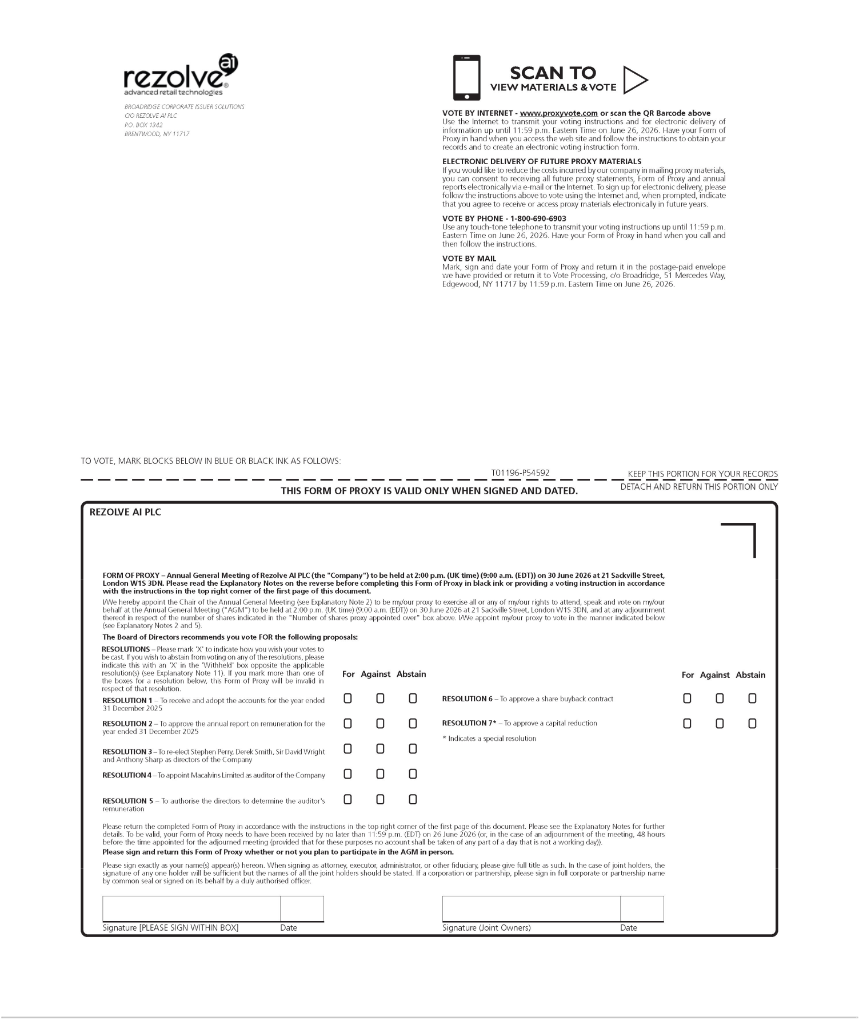

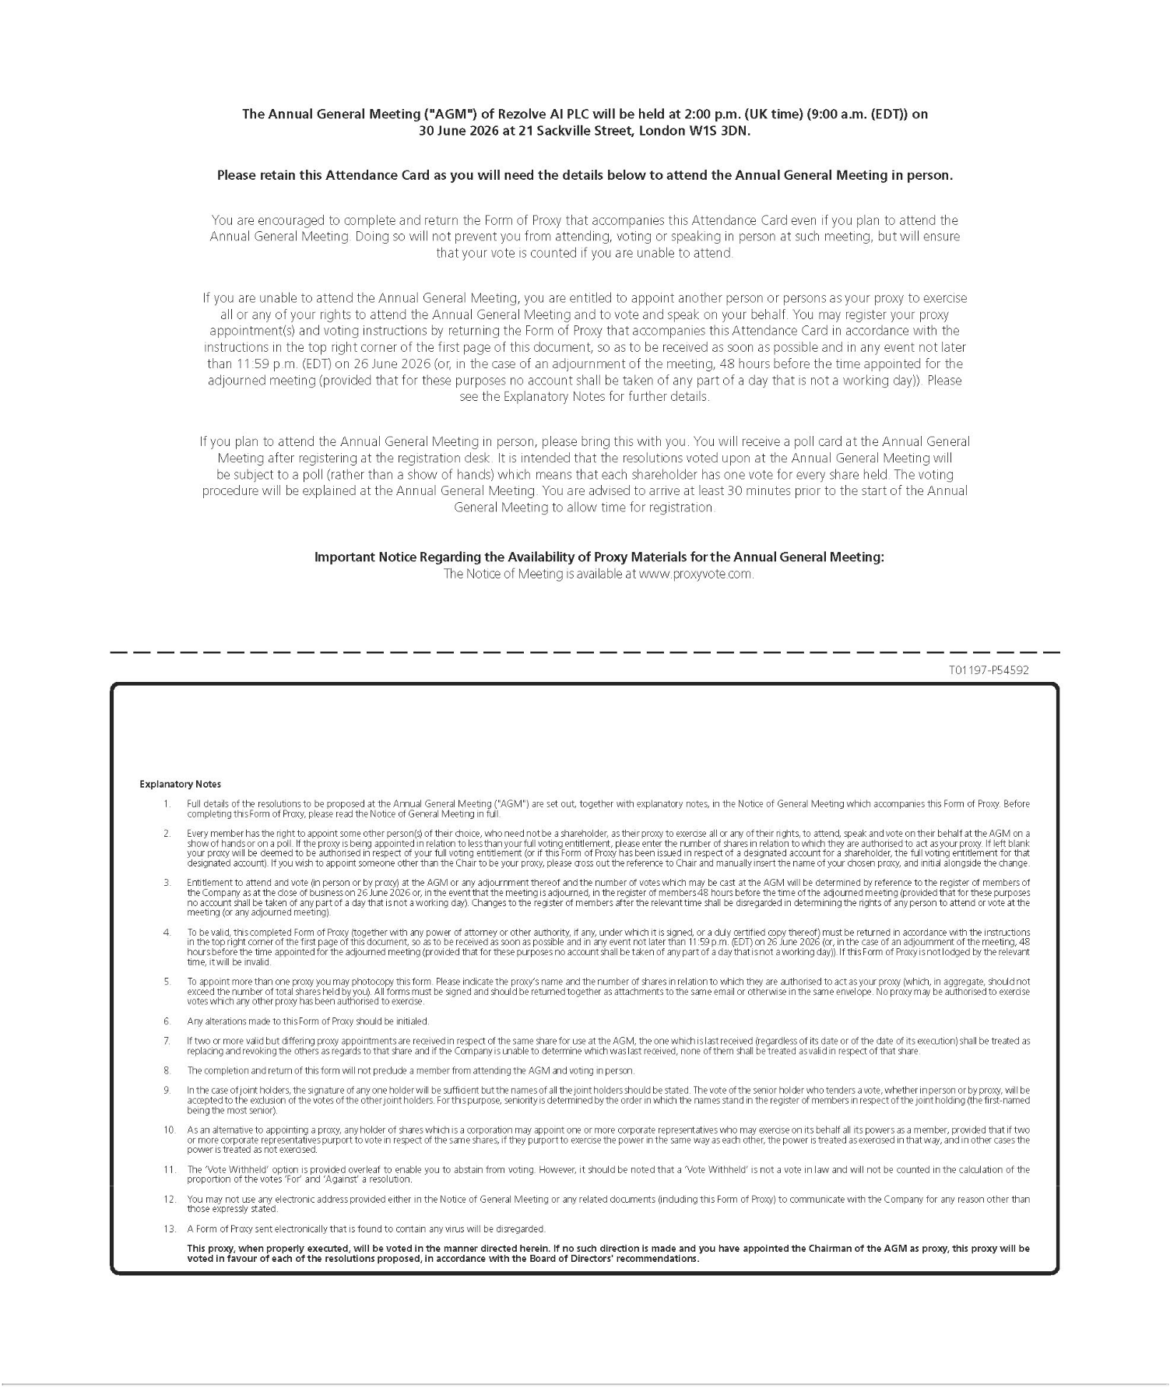

Exhibit 99.3

Rezolve Ai Board Moves to Authorize Capital Reduction and Up to $300 Million Share Repurchase Program

Proposed authorities would provide capital allocation flexibility as the Company intends to commence repurchases, while evaluating further non-dilutive funding alternatives for long-term shareholder value

NEW YORK - June 12, 2026: Rezolve Ai (NASDAQ: RZLV), (“Rezolve Ai” or the “Company”), a global leader in AI-powered commerce, today announced that its Board of Directors will seek authority at the Company’s upcoming annual general meeting to be held on June 30, 2026, to approve a capital reduction and an agreement with BTIG, a global financial services firm, enabling the Company to repurchase up to $300 million of ordinary shares.

The proposed program reflects the Board’s confidence in Rezolve Ai’s long-term prospects and its belief that the Company’s current public market valuation does not reflect the strength of the business, the progress achieved since listing, or the scale of the opportunity ahead. Under the agreement with BTIG, the Company will repurchase from BTIG ordinary shares that BTIG will acquire in the market, within agreed pricing parameters.

The Company intends to commence repurchases as soon as possible following Court approval of the capital reduction, utilizing existing cash reserves. To support the program over time, the Company is evaluating a range of potential non-dilutive financing alternatives and strategic capital initiatives which, if completed, could enhance Rezolve Ai’s flexibility to utilize the proposed repurchase authority over time, while also supporting other corporate priorities, including strategic M&A, balance sheet optimization and continued investment in growth. No assurance can be given that any such financing or capital initiative will be completed, or as to the timing, terms or amount of any repurchases.

Based on the Company’s existing voting arrangements, the Board expects the proposal to be approved, and current expectations are that Court approval will be obtained by the end of August. The capital reduction is subject to a standard UK Court approval process, as required under the UK Companies Act 2006.

The program will provide Rezolve Ai with the flexibility to repurchase ordinary shares from BTIG from time-to-time which BTIG has acquired through open market purchases, privately negotiated transactions, block trades, trading plans or other legally permissible methods. The timing, amount and method of any repurchases will be determined by the Company based on market conditions, share price, trading volume, liquidity, capital allocation priorities, legal requirements and other relevant factors.

Daniel M. Wagner, Chairman and Chief Executive Officer of Rezolve Ai, said:

“Rezolve Ai has made exceptional progress as a public company. We have strengthened our technology platform, expanded our commercial opportunity, advanced our strategic partnerships and continued to build a business positioned at the center of the AI-powered commerce revolution.

“Against that backdrop, the Board believes the current market valuation materially undervalues Rezolve Ai.

“Through a share repurchase program we are making a clear statement of confidence in the Company’s future and in the value we believe exists for shareholders.

The proposed repurchase program will not obligate the Company to acquire any specific number or dollar amount of shares and may be suspended, modified or discontinued at any time. Any repurchases will be made in compliance with applicable securities laws and other legal requirements.

Further details regarding the proposed share repurchase authority will be included in the Company’s shareholder materials and subsequent public filings.

ENDS

About Rezolve Ai

Rezolve Ai (NASDAQ: RZLV) is building the infrastructure layer for AI-driven commerce. Through Brain Suite, the world's first enterprise AI platform purpose-built for Agentic Commerce, Rezolve enables retailers, brands, and financial institutions to engage consumers in real time and execute transactions directly through AI-powered experiences.

Headquartered in London with operations across North America, Europe, and Asia, Rezolve Ai partners with leading global brands and retailers to power the future of commerce through AI that sells.

For more information, visit www.rezolve.com.

Investor Contact

Investors@rezolve.com

Media Contact

Urmee Khan

Global Head of Communications Rezolve Ai

urmeekhan@rezolve.com
+44 7576 094 040

Forward-Looking Statements

This press release contains forward-looking statements within the meaning of the federal securities laws, including statements regarding the Company’s intention to seek shareholder authority for a share repurchase program, the expected approval of such authority, the potential size and implementation of the program, the Company’s capital allocation strategy, potential non-dilutive financing alternatives, strategic capital initiatives, potential M&A activity, market valuation, operating momentum, strategic position, growth prospects and long-term value creation.

Forward-looking statements are based on current expectations and assumptions and are subject to risks and uncertainties that could cause actual results to differ materially from those expressed or implied. These risks include, among others, risks relating to the implementation of the proposed

share repurchase program, market volatility, changes in trading liquidity, legal and regulatory restrictions, capital allocation requirements, business performance and other risks described in the Company’s filings with the Securities and Exchange Commission.

Rezolve Ai undertakes no obligation to update any forward-looking statements, except as required by law.

